Joana Taraj-Software Modelling
SIS-FR-015 — Record Attendance
The system shall allow faculty members to record attendance for each class session, marking each enrolled student as Present, Absent, or Late.
- Use case table
Field | Description
Use Case ID | UC_015
Use Case Name | Record Attendance
Requirement ID | SIS-FR-015
Primary Actor | Faculty Member
Supporting Actors | Student
Description | Faculty records attendance for students enrolled in a course session.
Preconditions | Faculty member is logged into the system and has access to the selected course.
Trigger | Faculty selects “Record Attendance.”
Main Flow | 1. Faculty selects course. 2. System displays enrolled students. 3. Faculty marks students as Present, Absent, or Late. 4. Faculty submits attendance. 5. System validates attendance records. 6. System saves attendance data. 7. Confirmation message is displayed.
Alternative Flow | If students are not enrolled, the system displays “No students found.”
Postconditions | Attendance records are successfully stored in the system database.
Priority | 1

- Activity Diagram
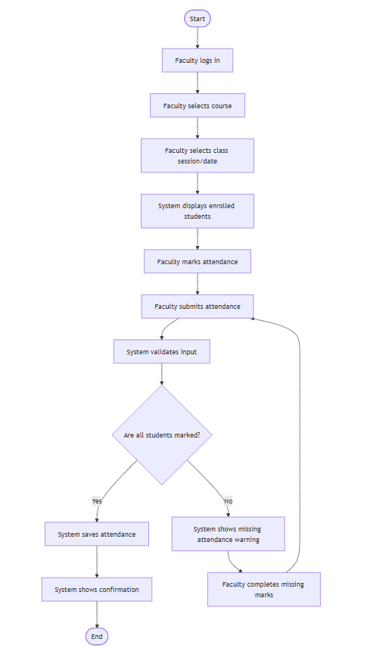

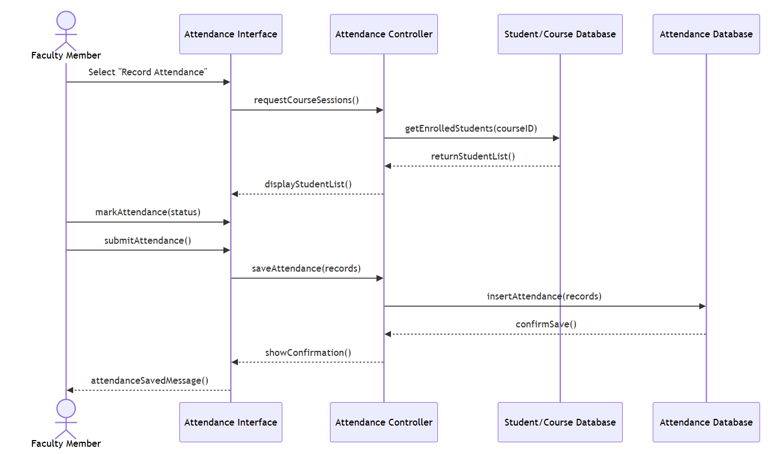
- Sequence Diagram

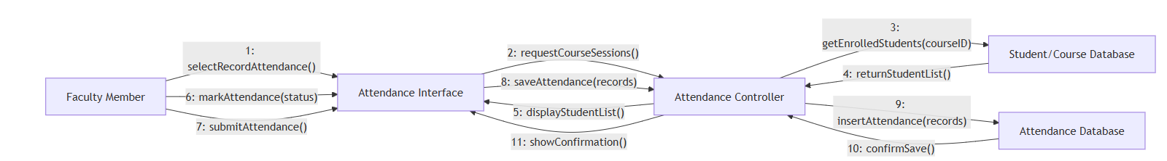
- Communication diagram

